Long short tern memory

What is LSTM?
LSTM (Long Short-Term Memory) is a recurrent neural network (RNN) architecture widely used in Deep Learning. It excels at capturing long-term dependencies, making it ideal for sequence prediction tasks.
Unlike traditional neural networks, LSTM incorporates feedback connections, allowing it to process entire sequences of data, not just individual data points. This makes it highly effective in understanding and predicting patterns in sequential data like time series, text, and speech.
LSTM has become a powerful tool in artificial intelligence and deep learning, enabling breakthroughs in various fields by uncovering valuable insights from sequential data.
LSTM Architecture
In the introduction to long short-term memory, we learned that it resolves the vanishing gradient problem faced by RNN, so now, in this section, we will see how it resolves this problem by learning the architecture of the LSTM. At a high level, LSTM works very much like an RNN cell. Here is the internal functioning of the LSTM network. The LSTM network architecture consists of three parts, as shown in the image below, and each part performs an individual function.
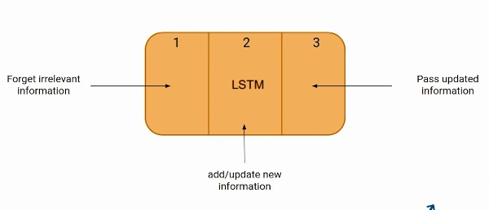
The Logic Behind LSTM
The first part chooses whether the information coming from the previous timestamp is to be remembered or is irrelevant and can be forgotten. In the second part, the cell tries to learn new information from the input to this cell. At last, in the third part, the cell passes the updated information from the current timestamp to the next timestamp. This one cycle of LSTM is considered a single-time step.
These three parts of an LSTM unit are known as gates. They control the flow of information in and out of the memory cell or lstm cell. The first gate is called Forget gate, the second gate is known as the Input gate, and the last one is the Output gate. An LSTM unit that consists of these three gates and a memory cell or lstm cell can be considered as a layer of neurons in traditional feedforward neural network, with each neuron having a hidden layer and a current state.
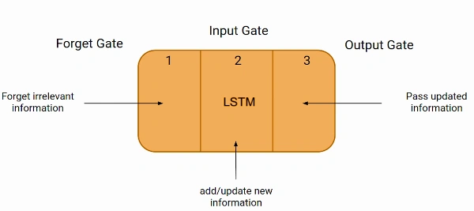
Just like a simple RNN, an LSTM also has a hidden state where H(t-1) represents the hidden state of the previous timestamp and Ht is the hidden state of the current timestamp. In addition to that, LSTM also has a cell state represented by C(t-1) and C(t) for the previous and current timestamps, respectively.
Here the hidden state is known as Short term memory, and the cell state is known as Long term memory. Refer to the following image.
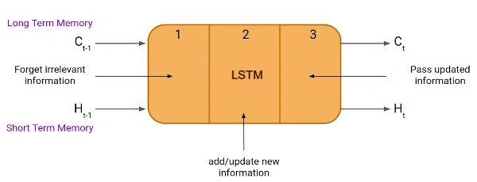
It is interesting to note that the cell state carries the information along with all the timestamps.
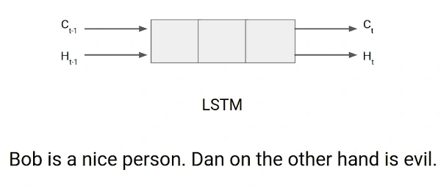
Example of LTSM Working
Let’s take an example to understand how LSTM works. Here we have two sentences separated by a full stop. The first sentence is “Bob is a nice person,” and the second sentence is “Dan, on the Other hand, is evil”. It is very clear, in the first sentence, we are talking about Bob, and as soon as we encounter the full stop(.), we started talking about Dan.
As we move from the first sentence to the second sentence, our network should realize that we are no more talking about Bob. Now our subject is Dan. Here, the Forget gate of the network allows it to forget about it. Let’s understand the roles played by these gates in LSTM architecture.
Forget Gate
In a cell of the LSTM neural network, the first step is to decide whether we should keep the information from the previous time step or forget it. Here is the equation for forget gate.
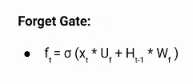
Let’s try to understand the equation, here
- Xt: input to the current timestamp.
- Uf: weight associated with the input
- Ht-1: The hidden state of the previous timestamp
- Wf: It is the weight matrix associated with the hidden state
Later, a sigmoid function is applied to it. That will make ft a number between 0 and 1. This ft is later multiplied with the cell state of the previous timestamp, as shown below.
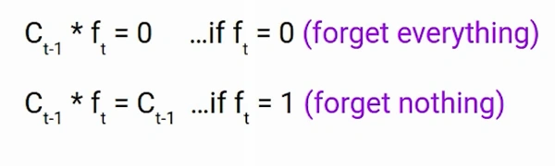
Input Gate
Let’s take another example.
“Bob knows swimming. He told me over the phone that he had served the navy for four long years.”
So, in both these sentences, we are talking about Bob. However, both give different kinds of information about Bob. In the first sentence, we get the information that he knows swimming. Whereas the second sentence tells, he uses the phone and served in the navy for four years.
Now just think about it, based on the context given in the first sentence, which information in the second sentence is critical? First, he used the phone to tell, or he served in the navy. In this context, it doesn’t matter whether he used the phone or any other medium of communication to pass on the information. The fact that he was in the navy is important information, and this is something we want our model to remember for future computation. This is the task of the Input gate.
The input gate is used to quantify the importance of the new information carried by the input. Here is the equation of the input gate
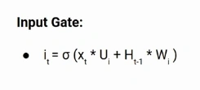
Here,
- Xt: Input at the current timestamp t
- Ui: weight matrix of input
- Ht-1: A hidden state at the previous timestamp
- Wi: Weight matrix of input associated with hidden state
Again we have applied the sigmoid function over it. As a result, the value of I at timestamp t will be between 0 and 1.
New Information
Now the new information that needed to be passed to the cell state is a function of a hidden state at the previous timestamp t-1 and input x at timestamp t. The activation function here is tanh. Due to the tanh function, the value of new information will be between -1 and 1. If the value of Nt is negative, the information is subtracted from the cell state, and if the value is positive, the information is added to the cell state at the current timestamp.
However, the Nt won’t be added directly to the cell state. Here comes the updated equation:
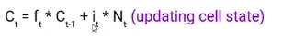
Here, Ct-1 is the cell state at the current timestamp, and the others are the values we have calculated previously.
Output Gate
Now consider this sentence.
“Bob single-handedly fought the enemy and died for his country. For his contributions, brave______.”
During this task, we have to complete the second sentence. Now, the minute we see the word brave, we know that we are talking about a person. In the sentence, only Bob is brave, we can not say the enemy is brave, or the country is brave. So based on the current expectation, we have to give a relevant word to fill in the blank. That word is our output, and this is the function of our Output gate.
Here is the equation of the Output gate, which is pretty similar to the two previous gates.
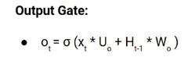
Its value will also lie between 0 and 1 because of this sigmoid function. Now to calculate the current hidden state, we will use Ot and tanh of the updated cell state. As shown below.
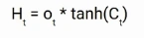
It turns out that the hidden state is a function of Long term memory (Ct) and the current output. If you need to take the output of the current timestamp, just apply the SoftMax activation on hidden state Ht.
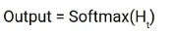
Here the token with the maximum score in the output is the prediction.
This is the More intuitive diagram of the LSTM network.
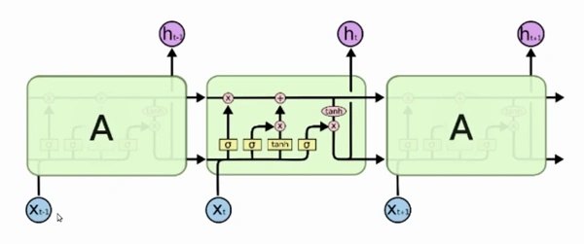
This diagram is taken from an interesting blog. I urge you all to go through it. Here is the link: Understanding LSTM Networks!
LTSM vs RNN
If you are looking to kick-start your Data Science Journey and want every topic under one roof, your search stops here. Check out Analytics Vidhya’s Certified AI & ML BlackBelt Plus Program.
What are Bidirectional LSTMs?
Bidirectional LSTMs (Long Short-Term Memory) are a type of recurrent neural network (RNN) architecture that processes input data in both forward and backward directions. In a traditional LSTM, the information flows only from past to future, making predictions based on the preceding context. However, in bidirectional LSTMs, the network also considers future context, enabling it to capture dependencies in both directions.
The bidirectional LSTM comprises two LSTM layers, one processing the input sequence in the forward direction and the other in the backward direction. This allows the network to access information from past and future time steps simultaneously. As a result, bidirectional LSTMs are particularly useful for tasks that require a comprehensive understanding of the input sequence, such as natural language processing tasks like sentiment analysis, machine translation, and named entity recognition.
By incorporating information from both directions, bidirectional LSTMs enhance the model’s ability to capture long-term dependencies and make more accurate predictions in complex sequential data.
Conclusion
In this article, we covered the basics and sequential architecture of a Long Short-Term Memory Network model. Knowing how it works helps you design an LSTM model with ease and better understanding. It is an important topic to cover as LSTM models are widely used in artificial intelligence for natural language processing tasks like language modeling and machine translation. Some other applications of lstm are speech recognition, image captioning, handwriting recognition, time series forecasting by learning time series data, etc.
If you are looking to kick-start your Data Science Journey and want every topic under one roof, your search stops here. Check out Analytics Vidhya’s Certified AI & ML BlackBelt Plus Program.

Long Short Term Memory: Predict the Next Word
Introduction
Predict next word LSTM(Natural language processing) has been an area of research and used widely in different applications. We often love texting each other and find that whenever we try to type a text a suggestion poops up trying to predict the next word we want to write. This process of prediction is one of the applications NLP deals with. We have made huge progress here and we can use Recurrent neural networks for such a process. There have been difficulties in basic RNN and you can find it here.
This article deals with how we can use a neural model better than a basic RNN and use it to predict the next word. We deal with a model called Long Short term Memory (LSTM).
“LSTM (Long Short-Term Memory) is utilized for modeling long-term dependencies in sequential data or sequence of words , allowing it to capture and remember information over extended periods within a sequence.”
We can use the TensorFlow library in python for building and training the deep learning model.
This article was published as a part of the Data Science Blogathon
Learning Objectives
- Understand the Fundamentals of Long Short-Term Memory(LSTM) networks.
- Learn to implement LSTM using TensorFlow and Keras.
- Gain hands-on experience with code snippets for model building, training, and saving
- Apply the LSTM model to do next word prediction in the provided sentences.

Why use LSTM?
Vanishing gradient descend is a problem faced by neural networks when we go for backpropagation as discussed here. It has a huge effect and the weight update process is widely affected and the model became useless. So, we used LSTM which has a hidden state and a memory cell with three gates that are forgotten, read, and input gate.
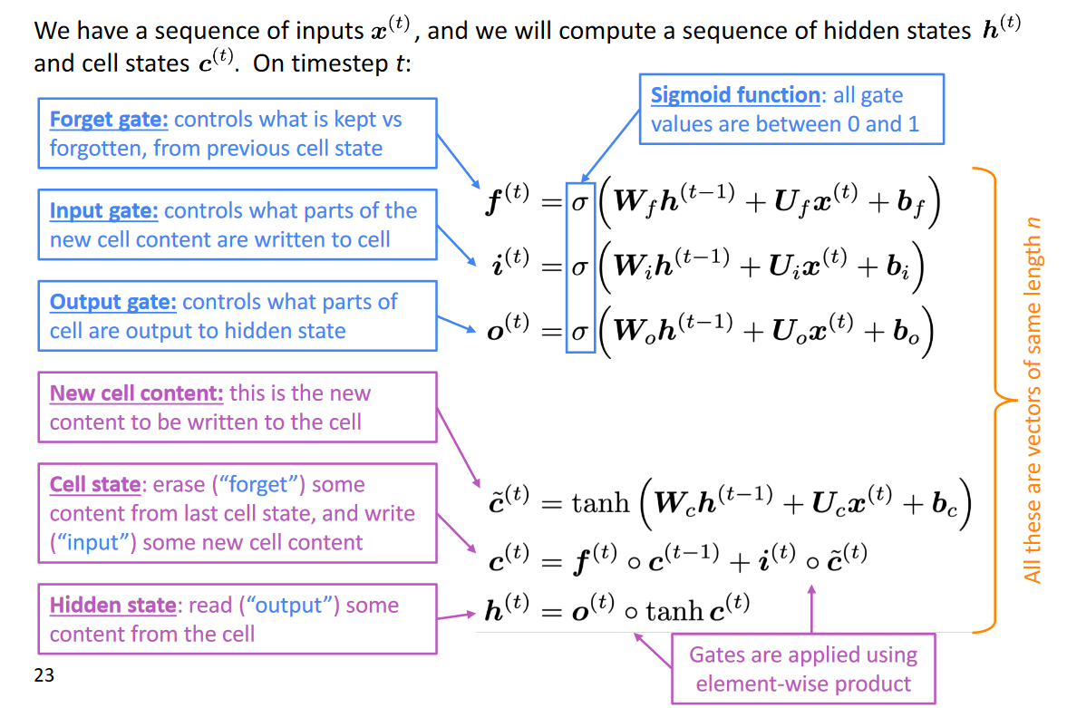
The following figure helps us understand how these gates work. The forget gate is mainly used to get good control of what information needs to be removed which isn’t necessary. Input gate makes sure that newer information is added to the cell and output makes sure what parts of the cell are output to the next hidden state. The sigmoid function used in each gate equation makes sure we can bring down the value to either a 0 or 1.
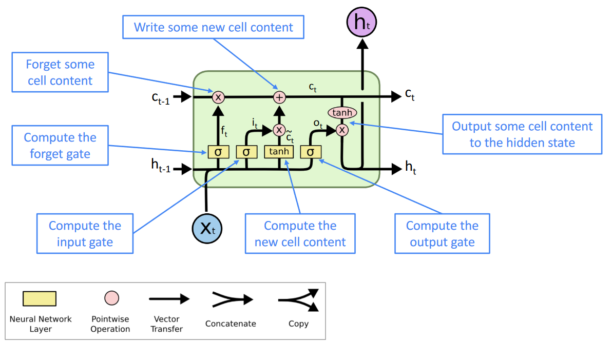
The exact model architecture of an LSTM is shown in this figure. Here, X is the word subscript t indicates that time instant. As we can see, c and h are input coming from an earlier time or the last step. We have the forget gate that controls the weights so that it can exactly know what information needs to be removed before going to the next gate. We use sigmoid here. The input I am added and some new information is written in the cell at that time instant. Finally, the output gate outputs the information that is given to the next LSTM cell.
Num of layers:
The number of layers in an LSTM network is a hyperparameter that can be tuned to improve the performance of the network. The number of layers determines the depth of the network, and a deeper network can learn more complex relationships in the data. However, a deeper network also requires more training data and can be more difficult to train.
Num of units:
The number of units in an LSTM layer is another hyperparameter that can be tuned to improve the performance of the network. The number of units determines the width of the network, and a wider network can learn more complex relationships in the data. However, a wider network also requires more training data and can be more difficult to train.
Prediction of next word
Till now we saw how an LSTM works and its architecture. Now comes the application part. Predicting the next word is a neural application that uses Recurrent neural networks. Since basic recurrent neural networks have a lot of flows we go for LSTM. Here we can make sure of having longer memory of what words are important with help of those three gates we saw earlier.
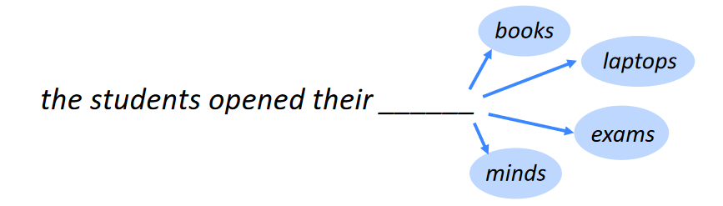
The following diagram tells us exactly what we are trying to deal with. What could be the next word? We will build a neural model to predict this. The dataset used is available here. I have followed this code from this tutorial.
1. Import the required libraries
We use TensorFlow with Keras for our model building. We can import the LSTM model from Keras and use it. For different NLP tasks, we can use the NLTK library.
import numpy as np
import heapq
import matplotlib.pyplot as plt
from nltk.tokenize import RegexpTokenizer
from keras.models import Sequential, load_model
from keras.layers.core import Dense, Activation
from keras.layers import LSTM
from keras.preprocessing.sequence import pad_sequences
from keras.preprocessing.text import one_hot
from keras.preprocessing.text import Tokenizer
import pickle
from keras.optimizers import RMSprop
2. Read the dataset
We can check the length of the corpus by using the len function on text after reading and converting everything to lower case to avoid duplication of words.
path = 'data.txt'
text = open(path).read().lower()
print('length of the corpus is: :', len(text))
length of the corpus is: 581887
length of the corpus is: 581887
3. Using tokenizers
The tokenizers are required so that we can split into each word and store them.
tokenizer = RegexpTokenizer(r'\w+')
words = tokenizer.tokenize(text)
4. Getting unique words
We get all the unique words and we require a dictionary with each word in the data within the list of unique words as the key and its significant portions as value.
tokenizer = Tokenizer()
tokenizer.fit_on_texts(words)
unique_word_index = tokenizer.word_index
5. Feature Engineering
Feature engineering will make the words into numerical representation so that it is easy to process them.
SEQUENCE_LENGTH = 5
prev_words = []
next_words = []
for i in range(len(words) - SEQUENCE_LENGTH):
prev_words.append(words[i:i + SEQUENCE_LENGTH])
next_words.append(words[i + SEQUENCE_LENGTH])
6. Storing features and labels
X will be used to get the features and Y to get the labels associated with them.
X = np.zeros((len(prev_words), SEQUENCE_LENGTH], len(unique_word_index)), dtype=bool)
Y = np.zeros((len(next_words), len(unique_word_index)), dtype=bool)
for i, each_words in enumerate(prev_words):
for j, each_word in enumerate(each_words):
X[i, j, unique_word_index[each_word]] = 1
Y[i, unique_word_index[next_words[i]]] = 1
7. Building our model
We can see that we have built an LSTM model and used a softmax activation at the end to get few specific words predicted by the model.
model = Sequential()
model.add(LSTM(128, input_shape=(SEQUENCE_LENGTH, len(unique_word_index))))
model.add(Dense(len(unique_word_index)))
model.add(Activation('softmax'))
model.summary()
8. Model training
The model training uses RMSprop as the optimizer with a learning rate of 0.02 and uses categorical cross-entropy for loss function. With a batch size of 128 and a split of 0.5, we train our model.
optimizer = RMSprop(lr=0.01)
model.compile(loss='categorical_crossentropy', optimizer=optimizer, metrics=['accuracy'])
history = model.fit(X, Y, validation_split=0.05, batch_size=128, epochs=2, shuffle=True).history
8. Saving model
The model is saved using the save function and loaded.
model.save('next_word_model.h5')
pickle.dump(history, open("history.p", "wb"))
model = load_model('next_word_model.h5')
history = pickle.load(open("history.p", "rb"))
9. Evaluating the model
We can see the results of the models on evaluation.
plt.plot(history['accuracy'])
plt.plot(history['val_accuracy'])
plt.title('model accuracy')
plt.ylabel('accuracy')
plt.xlabel('epoch')
plt.legend(['train', 'test'], loc='upper left')
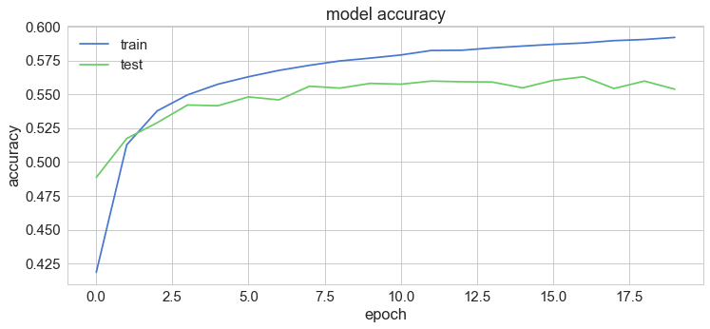
plt.plot(history['loss'])
plt.plot(history['val_loss'])
plt.title('model loss')
plt.ylabel('loss')
plt.xlabel('epoch')
plt.legend(['train', 'test'], loc='upper left')
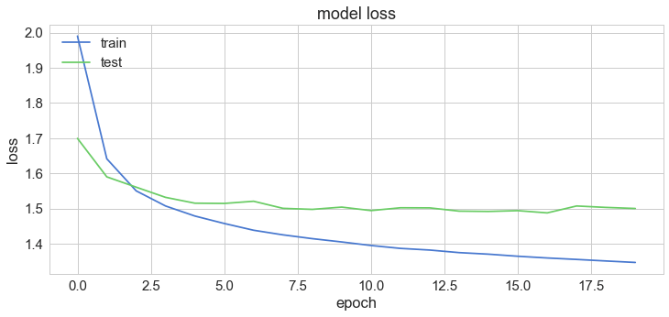
10. Testing next word
These functions will help us to predict the next few words when we provide a sentence.
def prepare_input(text):
x = np.zeros((1, SEQUENCE_LENGTH, len(unique_word_index)))
for t, word in enumerate(text):
x[0, t, unique_word_index[word]] = 1
return x

def sample(preds, top_n=3):
preds = np.asarray(preds).astype('float64')
preds = np.log(preds)
exp_preds = np.exp(preds)
preds = exp_preds / np.sum(exp_preds)
return heapq.nlargest(top_n, range(len(preds)), preds.take)

def predict_completions(text, n=3):
x = prepare_input(text)
preds = model.predict(x, verbose=0)[0]
next_indices = sample(preds, n)
return [indices_char[idx] + predict_completion(text[1:] + indices_char[idx]) for idx in next_indices]

quotes = [
"It is not a lack of love, but a lack of friendship that makes unhappy marriages.",
"That which does not kill us makes us stronger.",
"I'm not upset that you lied to me, I'm upset that from now on I can't believe you.",
"And those who were seen dancing were thought to be insane by those who could not hear the music.",
"It is hard enough to remember my opinions, without also remembering my reasons for them!"
]
11. Predict the next word
for q in quotes:
seq = q[:40].lower()
print(seq)
print(predict_completions(seq, 5))
print()
12. Result
The result will show us the words that can come next to the sentence we provided.
it is not a lack of love, but a lack of
['the ', 'an ', 'such ', 'man ', 'present, ']
that which does not kill us makes us str
['ength ', 'uggle ', 'ong ', 'ange ', 'ive ']
i'm not upset that you lied to me, i'm u
['nder ', 'pon ', 'ses ', 't ', 'uder ']
and those who were seen dancing were tho
['se ', 're ', 'ugh ', ' servated ', 't ']it is hard enough to remember my opinion
[' of ', 's ', ', ', 'nof ', 'ed ']
Conclusion
In summary, this article navigated the landscape of natural language processing, honing in on the predictive capabilities of Long Short-Term Memory (LSTM) networks. By addressing challenges like vanishing gradient descent, LSTM emerges as a powerful solution for sequential data, demonstrated in predicting the next word within a sentence.
The hands-on implementation using TensorFlow and Keras equipped readers with practical insights, emphasizing key machine learning concepts such as encoding, word embeddings, and text data preprocessing. Algorithmic sophistication met practicality through n-grams, tokenization, and careful consideration of input length and word sequences.
LSTM’s role in capturing context and dependencies highlighted its prowess in sequence prediction tasks. The article’s journey through encoding, preprocessing, and leveraging machine learning tools underscores its relevance in today’s data-driven landscape. Ultimately, this exploration provides a concise yet comprehensive guide to LSTM’s application in predicting the next word, blending theoretical understanding with practical implementation. You can practice the given code in and article and upload on your github.
Key Takeaways
- The article focused on the application of Long Short-Term Memory (LSTM) networks in natural language processing (NLP), particularly in predicting the next word in a given sequence.
- It highlighted the challenges faced by basic Recurrent Neural Networks (RNNs), such as vanishing gradient descent, and explained how LSTM overcomes these issues with its hidden state and memory cell equipped with forget, read, and input gates.
- Detailed explanation of the architecture of LSTM, emphasizing the role of gates (forget, input, and output gates) in managing information flow and capturing long-term dependencies in sequential data.
- Saving the trained model and loading it for future use, ensuring that the model can be applied without retraining.
The media shown in this article are not owned by Analytics Vidhya and are used at the Author’s discretion.

Introduction to Gated Recurrent Unit (GRU)
Introduction
In the ever-evolving world of artificial intelligence, Moreover, where algorithms mimic the human brain’s ability to learn from data, Recurrent Neural Networks (RNNs) have emerged as a powerful deep learning algorithm for processing sequential data. However, RNNs struggle with long-term dependencies within sequences. This is where Gated Recurrent Units (GRUs) come in. As a type of RNN equipped with a specific learning algorithm, GRUs address this limitation by utilizing gating mechanisms to control information flow, making them a valuable tool for various tasks in machine learning.
Objective
- In sequence modeling techniques, the Gated Recurrent Unit is the newest entrant after RNN and LSTM, hence it offers an improvement over the other two.
- Understand the working of GRU Activation Function and how it is different from LSTM
Note: If you are more interested in learning concepts in an Audio-Visual format, We have this entire article explained in the video below. If not, you may continue reading.
What is GRU?
GRU or Gated recurrent unit is an advancement of the standard RNN i.e recurrent neural network. It was introduced by Kyunghyun Cho et al in the year 2014.
GRUs are very similar to Long Short Term Memory(LSTM). Just like LSTM, GRU uses gates to control the flow of information. They are relatively new as compared to LSTM. This is the reason they offer some improvement over LSTM and have simpler architecture.
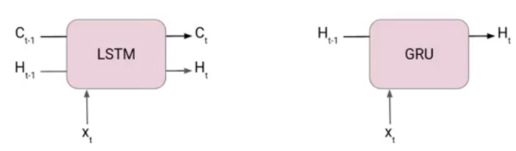
Another Interesting thing about GRU network is that, unlike LSTM, it does not have a separate cell state (Ct). It only has a hidden state(Ht). Due to the simpler architecture, GRUs are faster to train.
In case you are unaware of the LSTM network, I will suggest you go through the following article-Introduction to Long Short term Memory(LSTM).
Limitations of Standard RNN
Here are the limitations of standard RNNs in bullet points:
- Vanishing Gradient problem : This is a major limitation that occurs when processing long sequences. As information propagates through the network over many time steps, the gradients used to update the network weights become very small (vanish). This makes it difficult for the network to learn long-term dependencies in the data.
- Exploding Gradients: The opposite of vanishing gradients, exploding gradients occur when the gradients become very large during backpropagation. This can lead to unstable training and prevent the network from converging to an optimal solution.
- Limited Memory: Standard RNNs rely solely on the hidden state to capture information from previous time steps. This hidden state has a limited capacity, making it difficult for the network to remember information over long sequences.
- Difficulty in Training: Due to vanishing/exploding gradients and limited memory, standard RNNs can be challenging to train, especially for complex tasks involving long sequences.
How GRU Solve the Limitations of Standard RNN?
There are various types of recurrent neural network to solve the issues with standard RNN, GRU is one of them. Here’s how GRUs address the limitations of standard RNNs:
- Gated Mechanisms: Unlike standard RNNs, GRUs use special gates (Update gate and Reset gate) to control the flow of information within the network. These gates act as filters, deciding what information from the past to keep, forget, or update.
- Mitigating Vanishing Gradients: By selectively allowing relevant information through the gates, GRUs prevent gradients from vanishing entirely. This allows the network to learn long-term dependencies even in long sequences.
- Improved Memory Management: The gating mechanism allows GRU Activation Function to effectively manage the flow of information. The Reset gate can discard irrelevant past information, and the Update gate controls the balance between keeping past information and incorporating new information. This improves the network’s ability to remember important details for longer periods.
- Faster Training: Due to the efficient gating mechanisms, GRU Activation Function can often be trained faster than standard RNNs on tasks involving long sequences. The gates help the network learn more effectively, reducing the number of training iterations required.
The Architecture of Gated Recurrent Unit
Now lets’ understand how GRU works. Here we have a GRU cell which more or less similar to an LSTM cell or RNN cell.
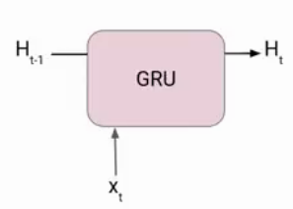
At each timestamp t, it takes an input Xt and the hidden state Ht-1 from the previous timestamp t-1. Later it outputs a new hidden state Ht which again passed to the next timestamp.
Now there are primarily two gates in a GRU as opposed to three gates in an LSTM cell. The first gate is the Reset gate and the other one is the update gate.
Reset Gate (Short term memory)
The Reset Gate is responsible for the short-term memory of the network i.e the hidden state (Ht). Here is the equation of the Reset gate.
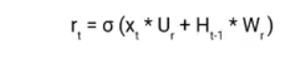
If you remember from the LSTM gate equation it is very similar to that. The value of rt will range from 0 to 1 because of the sigmoid function. Here Ur and Wr are weight matrices for the reset gate.
Update Gate (Long Term memory)
Similarly, we have an Update gate for long-term memory and the equation of the gate is shown below.
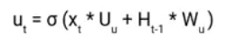
The only difference is of weight metrics i.e Uu and Wu.
How GRU Works?
Prepare the Inputs:
- The GRU takes two inputs as vectors: the current input (X_t) and the previous hidden state (h_(t-1)).
Gate Calculations:
- There are three gates in a GRU: Reset Gate, Update Gate, and Forget Gate (sometimes combined with Reset Gate). We’ll calculate the values for each gate.
- To do this, we perform an element-wise multiplication (like a dot product for each element) between the current input and the previous hidden state vectors. This is done separately for each gate, essentially creating “parameterized” versions of the inputs specific to each gate.
- Finally, we apply an activation function (a function that transforms the values) element-wise to each element in these parameterized vectors. This activation function typically outputs values between 0 and 1, which will be used by the gates to control information flow.
Now let’s see the functioning of these gates in detail. To find the Hidden state Ht in GRU, it follows a two-step process. The first step is to generate what is known as the candidate hidden state. As shown below
Candidate Hidden State
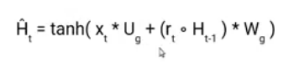
It takes in the current input and the hidden state from the previous timestamp t-1 which is multiplied by the reset gate output rt. Later passed this entire information to the tanh function, the resultant value is the candidate’s hidden state.
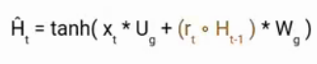
The most important part of this equation is how we are using the value of the reset gate to control how much influence the previous hidden state can have on the candidate state.
If the value of rt is equal to 1 then it means the entire information from the previous hidden state Ht-1 is being considered. Likewise, if the value of rt is 0 then that means the information from the previous hidden state is completely ignored.
Hidden State
Once we have the candidate state, it is used to generate the current hidden state Ht. It is where the Update gate comes into the picture. Now, this is a very interesting equation, instead of using a separate gate like in LSTM and GRU Architecture we use a single update gate to control both the historical information which is Ht-1 as well as the new information which comes from the candidate state.
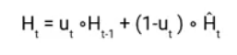
Now assume the value of ut is around 0 then the first term in the equation will vanish which means the new hidden state will not have much information from the previous hidden state. On the other hand, the second part becomes almost one that essentially means the hidden state at the current timestamp will consist of the information from the candidate state only.
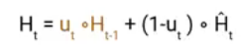
Similarly, if the value of ut is on the second term will become entirely 0 and the current hidden state will entirely depend on the first term i.e the information from the hidden state at the previous timestamp t-1.
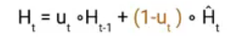
Hence we can conclude that the value of ut is very critical in this equation and it can range from 0 to 1.
In case, you are interested to know more about LSTM and GRU Architecture I suggest you read this Paper.
Advantages and Disadvantages of GRU
Advantages of GRU
- Faster Training and Efficiency: Compared to LSTMs (Long Short-Term Memory networks), GRUs have a simpler architecture with fewer parameters. This makes them faster to train and computationally less expensive.
- Effective for Sequential Tasks: GRUs excel at handling long-term dependencies in sequential data like language or time series. Their gating mechanisms allow them to selectively remember or forget information, leading to better performance on tasks like machine translation or forecasting.
- Less Prone to Gradient Problems: The gating mechanisms in GRUs help mitigate the vanishing/exploding gradient problems that plague standard RNNs. This allows for more stable training and better learning in long sequences.
Disadvantages of GRU
- Less Powerful Gating Mechanism: While effective, GRUs have a simpler gating mechanism compared to LSTMs which utilize three gates. This can limit their ability to capture very complex relationships or long-term dependencies in certain scenarios.
- Potential for Overfitting: With a simpler architecture, LSTM and GRU Architecture might be more susceptible to overfitting, especially on smaller datasets. Careful hyperparameter tuning is crucial to avoid this issue.
- Limited Interpretability: Understanding how a GRU Activation Function arrives at its predictions can be challenging due to the complexity of the gating mechanisms. This makes it difficult to analyze or explain the network’s decision-making process.
Applications of Gated Recurrent Unit
Here are some applications of GRUs where their ability to handle sequential data shines:
Natural Language Processing (NLP)
- Machine translation: GRUs can analyze the context of a sentence in one language and generate a grammatically correct and fluent translation in another language.
- Text summarization: By processing sequences of sentences, LSTM and GRU Architecture can identify key points and generate concise summaries of longer texts.
- Chatbots: GRUs can be used to build chatbots that can understand the context of a conversation and respond in a natural way.
- Sentiment Analysis: GRUs excel at analyzing the sequence of words in a sentence and understanding the overall sentiment (positive, negative, or neutral).
Speech Recognition
GRUs can analyze the sequence of audio signals in speech to transcribe it into text. They can be particularly effective in handling variations in speech patterns and accents.
Time Series Forecasting
GRUs can analyze historical data like sales figures, website traffic, or stock prices to predict future trends. Their ability to capture long-term dependencies makes them well-suited for forecasting tasks.
Anomaly Detection
GRUs can identify unusual patterns in sequences of data, which can be helpful for tasks like fraud detection or network intrusion detection.
Music Generation
GRUs can be used to generate musical pieces by analyzing sequences of notes and chords. They can learn the patterns and styles of different musical genres and create new music that sounds similar.
These are just a few examples, and the potential applications of GRUs continue to grow as researchers explore their capabilities in various fields.
Conclusion
Gated Recurrent Units (GRUs) represent a significant advancement in recurrent neural networks, addressing the limitations of standard RNNs. With their efficient gating mechanisms, GRUs effectively manage long-term dependencies in sequential data, making them valuable for various applications in natural language processing, speech recognition, and time series forecasting. While offering advantages like faster training and effective memory management, GRUs also have limitations such as potential overfitting and reduced interpretability. As AI continues to evolve, GRUs remain a powerful tool in the machine learning toolkit, balancing efficiency and performance for sequential data processing tasks.
Key Takeaways:
- Moreover, GRUs represent an advancement over standard RNNs, addressing their limitations by using gating mechanisms to control information flow.
- Specifically, the Reset Gate manages short-term memory, while the Update Gate controls long-term memory in GRUs.
- Additionally, GRUs feature a simpler architecture compared to Long Short-Term Memory (LSTM) networks, making them faster to train and computationally less expensive.
- Furthermore, GRUs excel at handling long-term dependencies in sequential data, making them valuable for tasks like machine translation, text summarization, and time series forecasting.

